IRIS Client-Sync – Disaster Recovery

Fig.1
Client-Sync Flowchart, indicating possible failure points

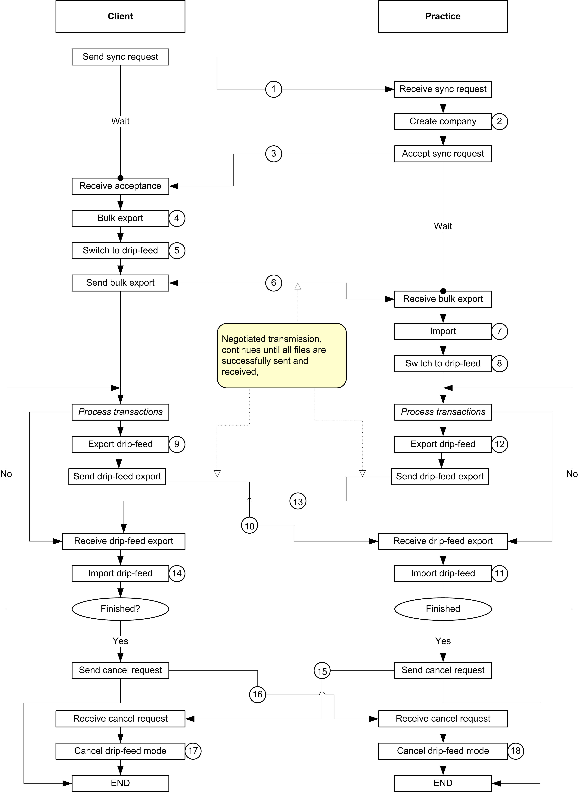

Failure Responses

Failure  Points | Possible failures | DSR Response | User Reponse/Issues
1 | Sync request not received by practice |  | Must resend from client.
2 | Create company fails |  | Must retry. Do not send sync acceptance.
3 | Sync acceptance not received by client. |  | Should resend from practice.  However, the sync acceptance message is currently sent automatically after Create Company, and cannot be resent.
4 | Bulk export fails. | Delete any XML files that were created, and retry. Do not activate drip-feed mode. | Drip-feed is activated when the Transactions are exported (the above flowchart is misleading about the exact point at which drip-feed mode is activated). Other files are exported after this, so if the export fails on these later files the system must be switched back out of drip-feed mode.
5 | Switch to drip-feed fails. |  | If the switch to drip-feed fails, the bulk export will be aborted.
6 | Bulk export not received by practice. | Retry until all files are received. | There is currently no facility to abort this.
6 | Bulk export only partially received by practice. | Retry until all files are received.
7 | Bulk import fails |  | There is currently no facility to retry the export/import if the import into the database fails.
8 | Switch to drip-feed fails. |  | If the switch to drip-feed fails, the bulk import will be aborted.
9 | Drip-feed export fails. | Delete any XML files that were created, and retry.
10 | Drip-feed export not received by practice. | Request a resend. | This has the same issues as Failure Point 6.
10 | Drip-feed export only partially received by practice. | Delete received files, and request a retry. | This has the same issues as Failure Point 6.
11 | Drip-feed import fails. |  | This has the same issues as Failure Point 7.
12,  13,  14 | These are essentially the same as Failure Points 9, 10, and 11, but from Practice to Client instead of Client to Practice.
15 | Cancel message not received by Client. |  | Must resend.
16 | Cancel message not received by Practice. |  | Must resend.
17 | Client fails to switch out of drip-feed mode. |  | Retry.
18 | Practice fails to switch out of drip-feed mode. |  | Retry.

